Meeting minutes | 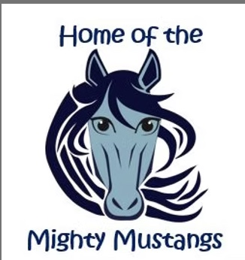
pta

Date: |  | Time: |  | Facilitator:
02/19/2026 |  | 7:00 PM |  | Jess Keim

Agenda
- Welcome
- Administrator Report
- Teacher Report
- Treasurer Update
- Shoe Orthodontics GOAT campaign
- Upcoming events
- 2026/2027 Board Elections

Administrator Report
Thanks for conference night dinner – perfect amount
Mid year assessment data is showing great progress
End of month reward (snowball fight) and all the kids loved it
Next month is glow party
Celebrating kindness week
Great thanks for all money raised during

Teacher Report
Staff thank you for conference dinner
50/50 preference between staff room refresh and t-shirts
- Problem with lounge is that two grades can’t fit in there at one time so many teachers don’t use it
- Possibly save up for a bigger project down the road

Treasurer Update
Reviewed transactions between Transactions between: 1/14/2026 - 2/19/2026
Current balance - $ 14,013.28

Shoe Orthodontics GOAT campaign
Teacher appreciation campaign where kids can nominate staff/teachers and the will be entered into monthly drawings

Upcoming events
- Kindness Pencils
  - $319 raised
- Yearbook
- Online orders due 4/10
- 5th grade parent messages due 2/27
- Hershey Park Fundraiser – orders due 3/2
- Science Fair – 4/9, 6-7:45 pm
  - About 30 students signed up so far
- Spring Fling + Silent Auction – 5/8, 5:30-7:30 pm
  - Requested Ms Collins send signup to teachers to volunteer for tattoo a teacher
- Teacher Appreciation Week – 5/4-5/8
- 5th Grade Farewell – 6/8, 10:30 am

Open Discussion
2026/2027 Board Elections
- Really looking for the “right” person to be the treasurer

Next meeting
THURSDAY, March 19th – IN PERSON

