Meeting minutes | 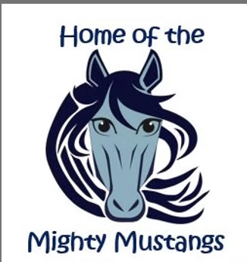
pta

Date: |  | Time: |  | Facilitator:
03/19/2026 |  | 7:00 PM |  | Jess Keim

Agenda
- Welcome
- Administrator Report
- Teacher Report
- Treasurer Update
- Upcoming events/activities
- Hershey Park Fundraiser
- Yearbook – orders due 4/10
- Plant Sale
- Science Fair – 4/9
- Spring Fling + Silent Auction – 5/8
- Teacher Appreciation Week – 5/4-5/8
- 5th Grade Farewell – 6/8
- Summer Bridge Program
- 2026/2027 Board Member Candidates
- Open Discussion

Administrator Report
Students reorganized based on mid year assessments
Getting ready for MCAP
Successful glow party – next reward will be outside with chalk, music, etc.

Teacher Report
Teachers questions in response to teacher appreciation lounge revamp
Suggests updates to the birthday calendar in the lounge
Suggested theme for teacher appreciation – Charlie and the Chocolate Factory – Teachers are our golden ticket

Treasurer Update
Reviewed transactions between Transactions between: 2/19/2026 - 3/19/2026
Current balance - $15,571.46
Reimbursed for 3rd and 5th field trips
Requested all allocation submissions by the April meeting
$340 made from Kindness Pencils

2026/2027 Board Member Candidates
Current Running:
Sarah Schulman – President
Lori Goldburg – Vice President
Jess Keim – Treasurer
Will vote at the May meeting
Absentee ballets will be distributed prior to that meeting

Upcoming events
- Hershey Park Fundraiser
$1,240.45 anticipated profit
Goal is to have tickets by the end of the month when the park opens
- Yearbook – orders due 4/10
Figure out how many extra yearbooks
- Plant Sale – 3/27
Ongoing and sales are going well – still need to send a school wide email
Will be ordering extra to sell at pickup and at Spring Fling
Not advertising and Susan will determine what to order
- Science Fair – 4/23
Students to register for a project and/or the demonstrations
- Spring Fling + Silent Auction – 5/8
Goal is the raise $15,000
Have started obtaining sponsors for the event
Anyone who knows of possible donation options, let the PTA know, we will do the legwork of contacting and collecting
Wristbands will be $15 in advance, $20 at the door
- Teacher Appreciation Week – 5/4-5/8
Theme will be “Friends” themed
Planned Weekly Agenda:
Lunch on Monday
Tuesday assembly (Bubbles?)
Wednesday – Admin Lunch
Snacks throughout the week
Gift card donation welcome and will be raffled off throughout the week
Thursday Snack Card
Friday is coffee truck
- 5th Grade Farewell – 6/8
Flyer requesting photos for slideshow and t-shirt sizes
Working on figuring out fundraising
- Summer Bridge Program
Raffle incentive for completing so many pages or a percentage returned in the fall – to be determined
- Raising Cane’s Community Offering
No charge to the school – certificates for free kids meals
Would work into existing incentive/reward programs

Open Discussion
Skate Night – Requesting April 18th
Possible request for Bus Stop and Ritas

Next meeting
THURSDAY, March 19th – IN PERSON

